Media Release
Experts Concerned Over Inaccurate Home Blood Pressure Devices

Hypertension, or high blood pressure, is the most important risk factor for heart attack, stroke and other complications. About 1 in 4 Canadians have hypertension, and a declining number of people have it under control.

Measuring your blood pressure at home is recommended by experts to help prevent the complications of high blood pressure. But, are these devices accurate?

On May 8th, Hypertension Canada hosted a webinar entitled, “The Problem of Unvalidated Home Blood Pressure Devices: Implications for Public Health and Practice,” where several experts weighed in on the scourge of unvalidated home blood pressure devices being sold in Canada. “Validation” is the scientific study of the accuracy of blood pressure devices. “Interestingly, there is no requirement for blood pressure devices to be tested for accuracy,” states Hypertension Canada president, Dr. Ross Tsuyuki.

Panelist Dr. Dean Picone from the University of Tasmania, Australia published a study in 2022 that showed that over three quarters of blood pressure devices available globally had no evidence of validation.

Closer to home, Jonathan Chan from the University of Alberta has conducted a similar review of home blood pressure devices sold in pharmacies and online in Canada. While he found that most home blood pressure devices sold in pharmacies were validated, but less than half sold online had any evidence of validation.

Dr. Swapnil Hiremath, who moderated the session stated, “The implications of inaccurate blood pressure devices are that measurements could be higher or lower than they really are, leading to overtreatment or undertreatment of high blood pressure, both of which would have important public health implications.”

In order to help the public make decisions about purchasing a home blood pressure device, Hypertension Canada publishes an online list of recommended blood pressure devices. Another easy way that people can ensure that their home blood pressure device is validated is to make sure any of the following three Hypertension Canada logos are on the box of the device or the listing online:

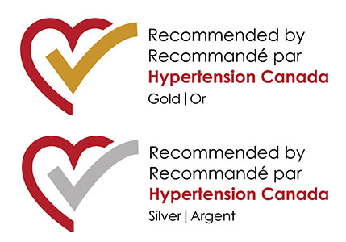

Hypertension Canada urges more device manufacturers to submit their blood pressure devices for validation in order to ensure that all Canadians are able to accurately measure their blood pressure at home. The public should seek the advice of a healthcare professional when purchasing a home blood pressure device and to make sure it is one that is recommended by Hypertension Canada.

For any further information, please contact Anna Stoutenburg at anna.stoutenburg@hypertension.ca.

