

Hello,

Thank you for registering for the Hypertension Canada Professional Certification Program.

The program is being delivered using the University of Alberta's eClass eLearning platform. To access the program, you will need to create an account and self-enrol in the course.

Follow these steps to get access to the course.

Creating An eClass Account
1. Follow this link: https://eclass-cpd.srv.ualberta.ca/course/view.php?id=561

2. This will take you to a page where you will create your account. Scroll to the bottom of the page for full instructions.

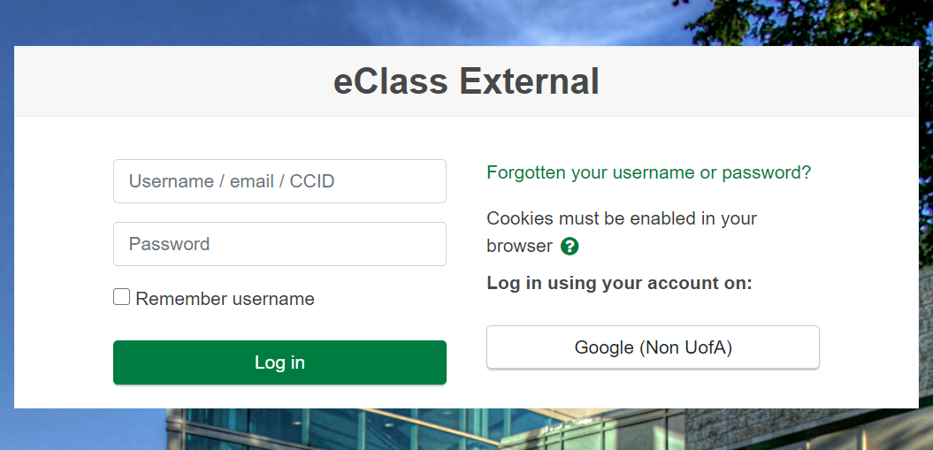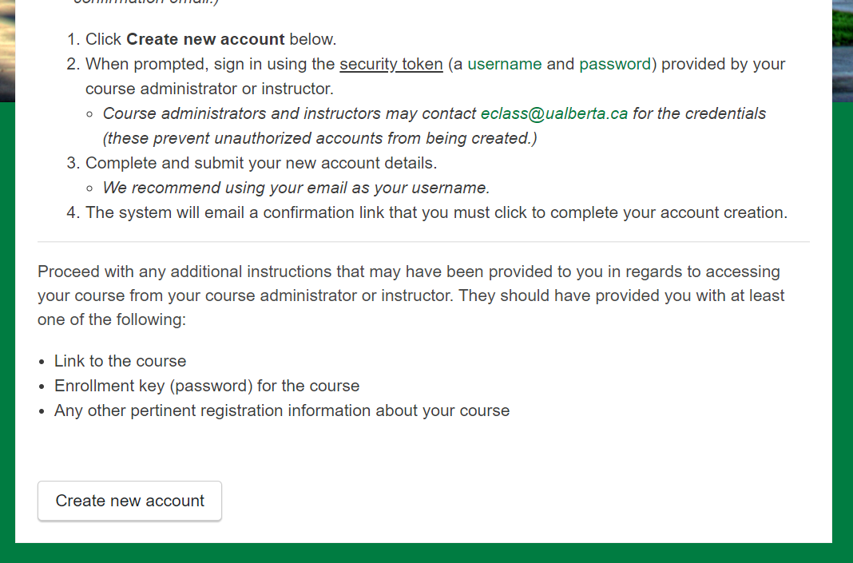

3. When you click on "Create new account" you will be prompted to enter a username and password. Use this information:
Username: external
Password: MoodleExternal2012

4. You will now be taken to an account creation screen. Please be sure to use an email where you can be contacted and the First Name and Last Name you would like to see on your certificate.

5. The system will send you an email to confirm your account. Click (or copy and paste) the HC-PCP link that is sent and confirm your account. It will take you back to the eClass system.

Enrolling in the Course
6. Once you confirm your account you will be taken to a page that asks for your self-enrolment key. If you don't see this page, then click on the link from step one (above) and it will appear.

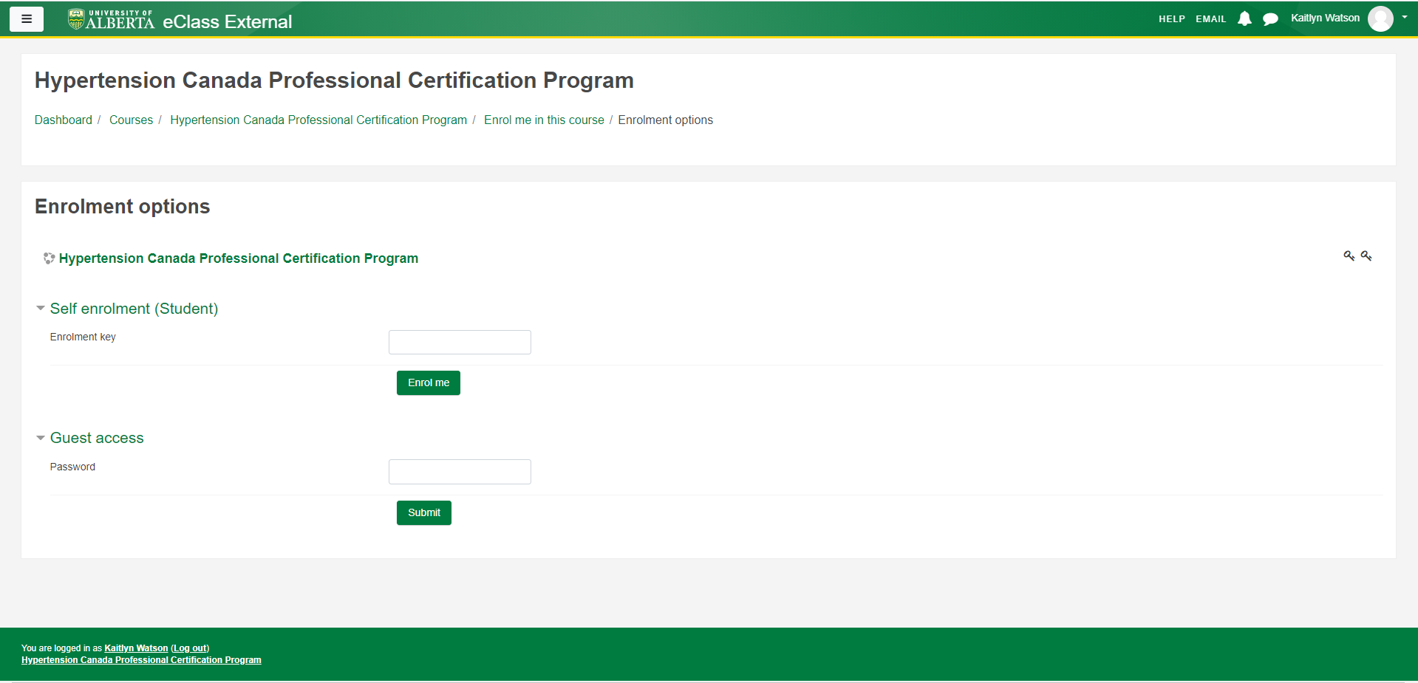

7. You will be asked to enter your Self enrolment key.

Your self-enrolment key is: y6"3XRTc)&

8. Use the link from step one each time you want to revisit the course. You will now have access to the course.

